CLOUD-ENABLED PREDICTIVE MAINTENANCE FRAMEWORK
FOR INDUSTRIAL EQUIPMENT
A CAPSTONE PROJECT REPORT
Submitted in partial fulfilment of the requirements for the Course of
CSA1558 – CLOUD COMPUTING AND BIG DATA ANALYTICS
to the award of the degree of
BACHELOR OF ENGINEERING
IN
COMPUTER SCIENCE AND ENGINEERING
Submitted by
Y. Vinodh Kumar (192472359)
Y. Sai Mohith (192372210)
S. Teja Yadav (192525447)
V. Venkata Siva Reddy (192311331)
Under the Supervision of
Dr. K. Santhiya Lakshmi


SIMATS ENGINEERING
Saveetha Institute of Medical and Technical Sciences
Chennai – 602105
SEPTEMBER 2026



SIMATS ENGINEERING
Saveetha Institute of Medical and Technical Sciences
Chennai-602105
BONAFIDE CERTIFICATE
This is to certify that the Capstone Project entitled “CLOUD-ENABLED PREDICTIVE MAINTENANCE FRAMEWORK FOR INDUSTRIAL EQUIPMENT” has been carried out by Y. Vinodh Kumar (192472359), Y. Sai Mohith (192372210), S. Teja Yadav (192525447), V. Venkata Siva Reddy (192311331) under the supervision of Dr. K. Santhiya Lakshmi and is submitted in partial fulfilment of the requirements for the current semester of the B.E. Computer Science and Engineering program at Saveetha Institute of Medical and Technical Sciences, Chennai.

COURSE COORDINATOR COURSE FACULTY
Dr. A. Gnana Soundari Dr. K. Santhiya Lakshmi
Professor Assistant Professor
Electrical and Electronic Engineering/Machine Learning Electronic and communication Engineering
SIMATS Engineering SIMATS Engineering

Submitted for the Project Work Viva-Voce held on: ____________________

INTERNAL EXAMINER EXTERNAL EXAMINER



SIMATS ENGINEERING
Saveetha Institute of Medical and Technical Sciences
Chennai-602105

DECLARATION
We, Y. Vinodh Kumar, Y. Sai Mohith, S. Teja Yadav, V. Venkata Siva Reddy of the B.E. Computer Science and Engineering program, SIMATS Engineering, Saveetha Institute of Medical and Technical Sciences, Chennai, hereby declare that the Capstone Project Work entitled “CLOUD-ENABLED PREDICTIVE MAINTENANCE FRAMEWORK FOR INDUSTRIAL EQUIPMENT” is the result of our own bonafide efforts. To the best of our knowledge, the work presented herein is original, accurate, and has been carried out in accordance with the principles of engineering ethics and academic integrity. All sources, references, data and other materials used in the project have been appropriately acknowledged.
We further declare that the data, results, analysis and findings presented in this report have not been fabricated, falsified or manipulated. The project has been planned, developed, tested and documented as a team activity, with individual responsibilities assigned for major modules. Any external software, datasets, cloud services and AI-assisted tools used during project preparation have been appropriately disclosed where applicable.
Place: Chennai
Date: 02-09-2026
Signature of the Students with Names
Y. Vinodh Kumar (192472359)
Y. Sai Mohith (192372210)
S. Teja Yadav (192525447)
V. Venkata Siva Reddy (192311331)



SIMATS ENGINEERING
Saveetha Institute of Medical and Technical Sciences
Chennai-602105

INDIVIDUAL CONTRIBUTION STATEMENT
Student Name /  Register No. | Specific Responsibilities | Design & Development | Testing & Analysis | Report Contribution | Approx. %
Y. Vinodh Kumar  192472359 | Module 1 – Data Collection & Cloud Data Management | Designed sensor-data ingestion workflow and data storage structure | Validated dataset consistency and storage records | Chapter 1, 2 and data management sections | 25%
Y. Sai Mohith  192372210 | Module 2 – Data Preprocessing & Big Data Analytics | Developed preprocessing and feature preparation workflow | Checked missing values, noise and transformed data | Chapter 2, 3 and analysis sections | 25%
S. Teja Yadav  192525447 | Module 3 – Machine Learning Prediction Engine | Selected and integrated prediction models | Evaluated predictions and interpreted performance | Chapter 3, 4 and results sections | 25%
V. Venkata Siva Reddy  192311331 | Module 4 – Dashboard, Alerts & System Integration | Designed Streamlit visualization and alert flow | Verified dashboard outputs and integrated modules | Chapter 4, 5 and implementation evidence | 25%

Total contribution: 100%

ABSTRACT
Predictive maintenance is increasingly important in modern industries because unexpected equipment failures can cause production delays, financial losses and high maintenance costs. Conventional reactive maintenance addresses faults only after failure, while scheduled preventive maintenance may result in unnecessary servicing. This project proposes a Cloud-Enabled Predictive Maintenance Framework for Industrial Equipment to support continuous monitoring and early prediction of possible machine failures. The framework uses simulated industrial sensor data, including temperature, vibration and pressure, to represent equipment operating conditions. The data is collected, preprocessed and managed through a cloud-enabled workflow to support scalable storage and analysis.
Machine learning techniques are used to identify abnormal operating patterns and predict potential equipment failure conditions. Data preparation includes handling missing values, reducing inconsistencies and transforming sensor features into a suitable form for model analysis. The prediction results are integrated with an interactive Streamlit dashboard that presents machine conditions, sensor trends, prediction status and maintenance alerts in an understandable visual form. The complete system is organized into four modules: data collection and cloud management, preprocessing and analytics, machine learning prediction, and dashboard and alert integration.
The proposed framework demonstrates a practical integration of cloud computing, big data concepts, Internet of Things data simulation and machine learning. Testing using representative sensor data verifies the end-to-end workflow from data acquisition to prediction and visualization. The framework provides a scalable basis for proactive maintenance decision-making and can be extended by connecting real industrial sensors, streaming platforms and commercial cloud services. The principal outcome of the project is an integrated predictive maintenance framework that supports improved equipment monitoring, reduced risk of unexpected downtime and more informed maintenance planning.
Keywords: Predictive Maintenance, Cloud Computing, Industrial IoT, Machine Learning, Big Data Analytics, Streamlit.

TABLE OF CONTENTS
Sl. No. | Title | Page No.
1 | Certificate from the Supervisor | ii
2 | Declaration by the Candidates | iii
3 | Individual Contribution Statement | iv
4 | Acknowledgement | v
5 | Abstract | vi
6 | List of Figures | vii
7 | List of Tables | viii
8 | List of Abbreviations | ix
9 | CHAPTER 1: INTRODUCTION AND ENGINEERING PROBLEM | 1
10 | 1.1 Background | 1
11 | 1.2 Need for the Project | 2
12 | 1.3 Problem Statement | 3
13 | 1.4 Project Aim | 3
14 | 1.5 Project Objectives | 4
15 | 1.6 Scope | 5
16 | 1.7 Expected Engineering Outcome | 6
17 | CHAPTER 2: LITERATURE REVIEW AND EXISTING SOLUTIONS | 7
18 | 2.1 Review Method | 7
19 | 2.2 Review of Existing Work | 8
20 | 2.3 Comparative Analysis | 10
21 | 2.4 Research / Engineering Gap | 11
22 | 2.5 Proposed Contribution | 12
23 | CHAPTER 3: ENGINEERING DESIGN, TRADE-OFFS, SUSTAINABILITY, ETHICS, SAFETY, RISK & SECURITY | 13
24 | 3.1 Requirements | 13
25 | 3.2 Constraints & Applicable Standards | 15
26 | 3.3 Design Specifications | 16
27 | 3.4 Alternative Solutions & Evaluation | 17
28 | 3.5 Selected Design & Detailed Design | 19
29 | 3.6 Trade-off Analysis | 21
30 | 3.7 Sustainability, Ethics, Safety, Risk & Security | 22
31 | CHAPTER 4: IMPLEMENTATION, TESTING & RESULTS, PROJECT MANAGEMENT | 25
32 | 4.1 Development Approach & Resources | 25
33 | 4.2 Implementation & Modern Tools Used | 27
34 | 4.3 Test Plan & Verification | 29
35 | 4.4 Results | 31
36 | 4.5 Data Analysis & Engineering Judgment | 33
37 | 4.6 Comparison with Existing Solutions & Achievement of Objectives | 34
38 | 4.7 Strengths & Limitations | 35
39 | 4.8 Project Planning, Roles & Budget | 36
40 | CHAPTER 5: CONCLUSION, FUTURE WORK AND REFLECTION | 39
41 | 5.1 Conclusion | 39
42 | 5.2 Future Work | 40
43 | 5.3 Professional Learning & Individual Reflection | 41
44 | References | 45
45 | Appendices | 47
46 | Capstone Project Outcome Mapping Sheet | 53

LIST OF FIGURES
Figure No. | Figure Name | Page No.
Fig. 3.1 | Proposed System Architecture | 19
Fig. 3.2 | System Data Flow / Module Interaction | 20
Fig. 4.1 | Implementation Workflow | 28
Fig. 4.2 | Cloud Data and Prediction Dashboard | 31
Fig. 4.3 | Prediction Performance / Results Visualization | 32
Fig. 4.4 | Project Milestone / Gantt Chart | 37

LIST OF TABLES
Table No. | Table Name | Page No.
Table 2.1 | Comparative Analysis of Existing Approaches | 10
Table 3.1 | Stakeholder / User Requirements | 13
Table 3.2 | Functional and Non-Functional Requirements | 14
Table 3.3 | Constraints and Applicable Standards | 15
Table 3.4 | Design Specifications | 16
Table 3.5 | Alternative Evaluation Matrix | 18
Table 3.6 | Trade-off Analysis | 21
Table 3.7 | Sustainability, Ethics, Safety and Security | 22
Table 3.8 | Risk Register | 24
Table 4.1 | Resources Used | 26
Table 4.2 | Tools and Technologies | 28
Table 4.3 | Test Plan and Verification | 29
Table 4.4 | Test Results Summary | 30
Table 4.5 | Objective Achievement | 34
Table 4.6 | Project Roles and Actual Contribution | 36
Table 4.7 | Project Budget | 38

LIST OF ABBREVIATIONS / SYMBOLS
Symbol / Term | Description | Unit
IoT | Internet of Things | –
ML | Machine Learning | –
RF | Random Forest | –
SVM | Support Vector Machine | –
CSV | Comma-Separated Values | –
API | Application Programming Interface | –
AWS | Amazon Web Services | –
CPU | Central Processing Unit | –

CHAPTER 1

INTRODUCTION AND ENGINEERING PROBLEM

1.1 Background
Industries depend heavily on machines and automated equipment for continuous production and efficient operations. Unexpected machine failures can lead to production delays, financial losses, safety concerns and increased maintenance costs. Traditional reactive maintenance responds after a fault occurs, whereas preventive maintenance follows fixed schedules that may not reflect the actual condition of equipment. Predictive maintenance addresses this limitation by using operating data to estimate equipment health and identify abnormal behaviour before a serious failure occurs.
The development of Industrial IoT, cloud computing, big data analytics and machine learning enables continuous collection and analysis of parameters such as temperature, vibration and pressure. Cloud-enabled infrastructure can support centralized storage and scalable processing, while machine learning can identify patterns that are difficult to evaluate manually. The proposed project integrates these technologies into a framework that converts simulated machine data into useful monitoring, prediction and alert information.

1.2 Need for the Project
The need for the project arises from the operational impact of unplanned equipment downtime. Maintenance engineers require timely information about machine condition so that maintenance can be planned before a complete breakdown. A connected framework is useful because industrial data may be generated continuously and in large volumes, requiring scalable processing and centralized access.
Need / Issue | Project Response
Unexpected failures cause downtime | Predictive analysis identifies abnormal operating patterns earlier
Maintenance data is fragmented | Cloud-enabled data management provides centralized access
Sensor readings are difficult to interpret manually | Machine learning supports pattern recognition and prediction
Maintenance teams need clear visibility | Dashboard presents trends, status and alerts

1.3 Problem Statement
Design and develop a cloud-enabled predictive maintenance framework capable of collecting or simulating industrial equipment sensor data, preprocessing and managing the data efficiently, applying machine learning to identify possible failure conditions, and presenting the resulting machine status through an interactive dashboard. The solution must balance scalability, data quality, prediction usefulness, implementation simplicity and ease of monitoring under realistic academic and prototype constraints.

1.4 Project Aim
To design and implement a cloud-enabled predictive maintenance framework for industrial equipment that uses sensor data, data analytics and machine learning to support early fault prediction and proactive maintenance decisions.

1.5 Project Objectives
- To design a scalable workflow for collecting and managing industrial sensor data.
- To preprocess temperature, vibration and pressure data for reliable analysis.
- To apply suitable machine learning techniques for equipment condition and failure prediction.
- To develop an interactive dashboard for monitoring, visualization and maintenance alerts.
- To test the end-to-end framework against defined functional and performance requirements.
- To evaluate the strengths, limitations and future scalability of the proposed approach.

1.6 Scope
The project includes simulated industrial sensor data, preprocessing, cloud-enabled data handling, machine learning based prediction and dashboard visualization. It focuses on an academic prototype demonstrating the complete predictive maintenance workflow. The present implementation does not claim deployment on a production industrial control system and does not replace certified safety or maintenance procedures. Real hardware sensors, large-scale live streaming and enterprise cloud deployment are considered future extensions.

1.7 Expected Engineering Outcome
The expected outcome is a working prototype framework that accepts machine-condition data, prepares the data for analysis, produces a prediction or machine-condition indication and presents the result through a user-friendly monitoring interface. The framework is expected to demonstrate system-level integration across data, analytics, prediction and visualization modules.

CHAPTER 2

LITERATURE REVIEW AND EXISTING SOLUTIONS

2.1 Review Method
The review was organized around predictive maintenance concepts, industrial IoT monitoring, cloud computing architectures, machine learning for condition monitoring and dashboard-based visualization. Existing maintenance strategies and representative technical resources were compared based on scalability, real-time capability, analytical intelligence, implementation cost and suitability for industrial monitoring.

2.2 Review of Existing Work
Reactive maintenance remains a basic approach in which equipment is repaired after failure. It is simple to implement but may result in long downtime and secondary damage. Preventive maintenance improves planning by scheduling service activities, but fixed intervals may cause unnecessary maintenance and may still miss unexpected faults.
Condition-based maintenance uses observed machine parameters to trigger maintenance when measured conditions exceed defined thresholds. This approach provides better responsiveness but depends on carefully selected rules. Modern predictive maintenance extends condition monitoring by using historical and current data with machine learning models to estimate the likelihood of abnormal conditions or failures.
Cloud-based industrial monitoring frameworks add scalable storage, remote accessibility and centralized data management. Machine learning methods such as Decision Tree and Random Forest are useful for prototype predictive analytics because they can learn relationships among sensor features and produce interpretable prediction outcomes. Streamlit provides a lightweight method of integrating data analysis and visualization into a single application.

2.3 Comparative Analysis
Existing Approach | Advantages | Limitations | Relevance to Proposed Work
Reactive maintenance | Simple and low initial monitoring cost | Failure occurs before action; high downtime risk | Used as baseline contrast
Preventive maintenance | Planned servicing and predictable schedules | May cause unnecessary maintenance; fixed intervals | Shows need for condition-aware decisions
Condition-based maintenance | Uses actual sensor measurements | Threshold rules may not capture complex patterns | Supports sensor monitoring concept
Cloud-based predictive maintenance | Scalable storage and remote access | Requires data integration and security controls | Core architecture concept
ML-based prediction | Learns patterns from data | Depends on data quality and validation | Core prediction technique

2.4 Research / Engineering Gap
Many approaches treat data collection, cloud storage, machine learning and visualization as separate technical tasks. The engineering gap addressed by this project is the need for a simple integrated prototype that demonstrates the complete path from industrial sensor data to a maintenance-oriented prediction and dashboard output. The project also emphasizes clear modular responsibilities so that each part of the system can be developed, tested and improved independently.

2.5 Proposed Contribution
The proposed contribution is an end-to-end cloud-enabled framework organized into four connected modules. Module 1 manages sensor-data collection and cloud-oriented storage. Module 2 prepares and analyzes the data. Module 3 performs machine learning based prediction. Module 4 presents results, alerts and system status through a Streamlit dashboard. This structure improves clarity, supports team-based development and provides a foundation for future integration with real sensors and cloud services.

CHAPTER 3

ENGINEERING DESIGN & TRADE-OFFS, SUSTAINABILITY, ETHICS, SAFETY, RISK & SECURITY

3.1 Requirements
Stakeholder | Requirement
Industrial organization | Reduced unexpected downtime and improved equipment visibility
Maintenance engineer | Clear machine status and timely warning information
Machine operator | Easy-to-understand monitoring interface
System administrator | Reliable data handling and maintainable software workflow
Project team | Modular implementation suitable for testing and demonstration

Requirement Type | Requirement | Measurable Target
Functional | Accept sensor records | Valid temperature, vibration and pressure fields are processed
Functional | Preprocess data | Missing/invalid values handled according to defined rules
Functional | Generate prediction | Model produces equipment-condition output for valid input
Functional | Visualize results | Dashboard displays sensor and prediction information
Non-Functional | Usability | Dashboard workflow understandable to project users
Non-Functional | Maintainability | Modules can be modified independently
Non-Functional | Scalability | Architecture can be extended to cloud storage and multiple machines

3.2 Constraints & Applicable Standards
Constraint / Standard | Requirement | How Applied in This Project
Data availability | No live industrial sensor installation in prototype | Simulated representative sensor data used and limitation documented
ISO 55000 principles | Asset management should support value and lifecycle decisions | Project focuses on information that supports proactive maintenance decisions
ISO/IEC 27001 security principles | Information assets require controlled handling | Access control, secure deployment and data protection are considered for future deployment
IEEE software engineering practices | Structured development, testing and documentation | Modular code, test planning and report documentation used
Academic constraints | Limited time, infrastructure and budget | Open-source Python tools and prototype-scale resources selected

3.3 Design Specifications
Parameter | Target / Requirement | Unit | Priority
Sensor inputs | Temperature, vibration, pressure | Mixed | High
Data preprocessing | Missing values and inconsistencies handled | – | High
Prediction output | Machine condition / possible failure indication | – | High
Visualization | Interactive monitoring and alerts | – | High
Architecture | Modular and extensible | – | High
Cost | Use predominantly open-source tools | INR | Medium

3.4 Alternative Solutions & Evaluation
Alternative 1: A purely rule-based threshold system would be simple and transparent, but its ability to capture interactions among multiple sensor variables is limited.
Alternative 2: A machine learning based cloud-enabled system can learn relationships from data and support centralized monitoring, but it requires suitable preprocessing and model validation.
Alternative 3: A deep learning and real-time streaming architecture offers greater future capability but introduces higher complexity, computing requirements and implementation effort for the current prototype.
Criterion | Weight | Alt. 1 Rule-Based | Alt. 2 ML + Cloud | Alt. 3 Deep Learning + Streaming
Performance | 0.30 | 3 | 5 | 5
Cost | 0.20 | 5 | 4 | 2
Safety / control clarity | 0.15 | 5 | 4 | 3
Sustainability / resource use | 0.10 | 4 | 4 | 2
Reliability | 0.15 | 3 | 5 | 4
Implementation feasibility | 0.10 | 5 | 5 | 2
Weighted suitability | 1.00 | 4.05 | 4.55 | 3.45

3.5 Selected Design & Detailed Design
The selected design is Alternative 2, the machine-learning and cloud-enabled framework, because it provides the best balance between analytical capability, implementation feasibility and scalability. It is more adaptable than a fixed threshold approach while remaining practical for the available project resources.

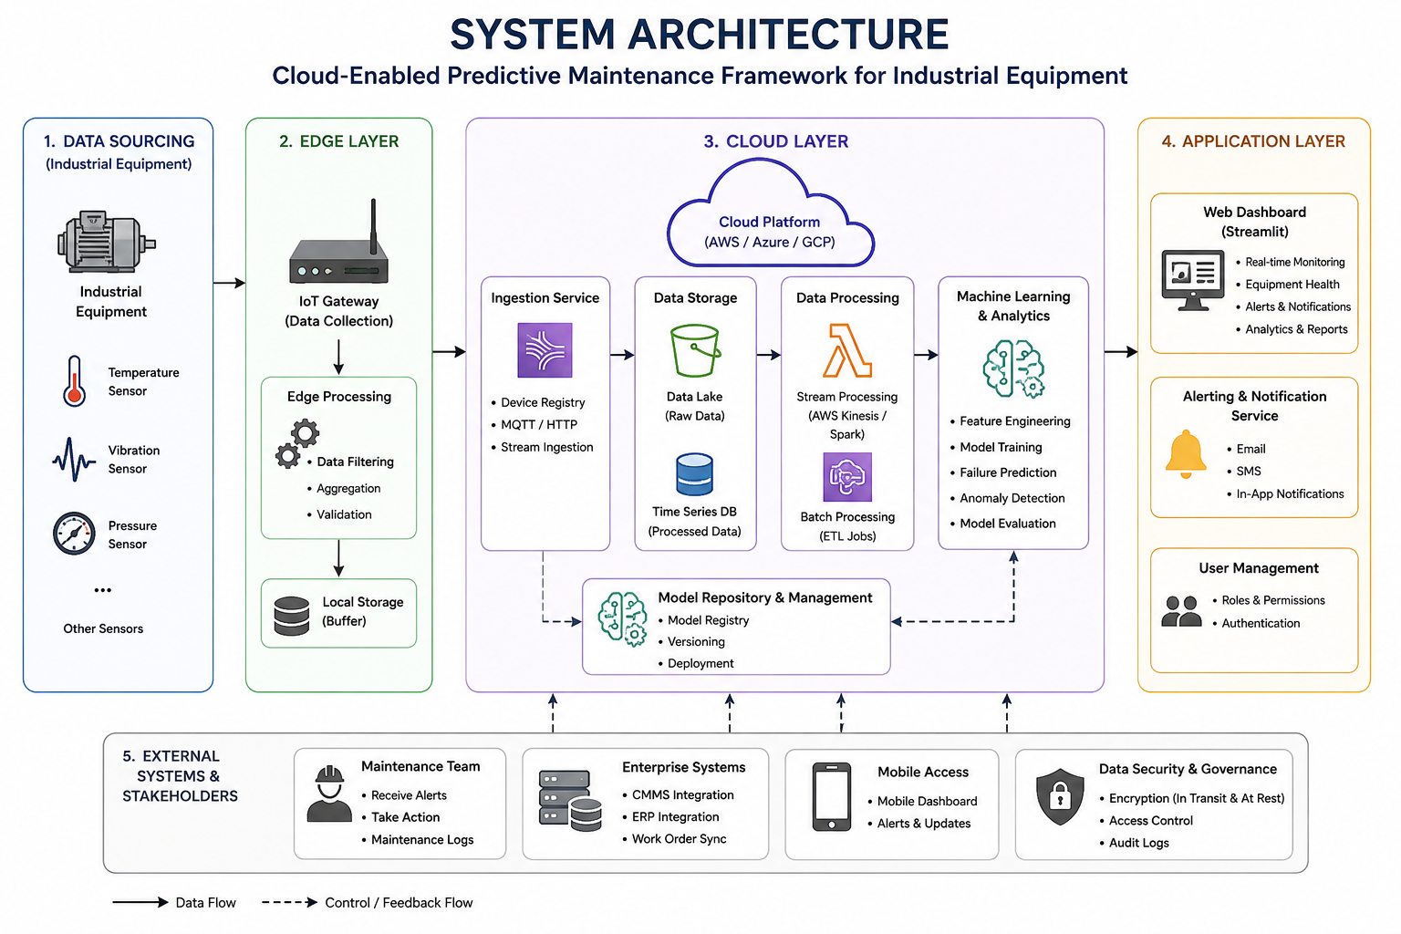
FIG. 3.1 – PROPOSED SYSTEM ARCHITECTURE
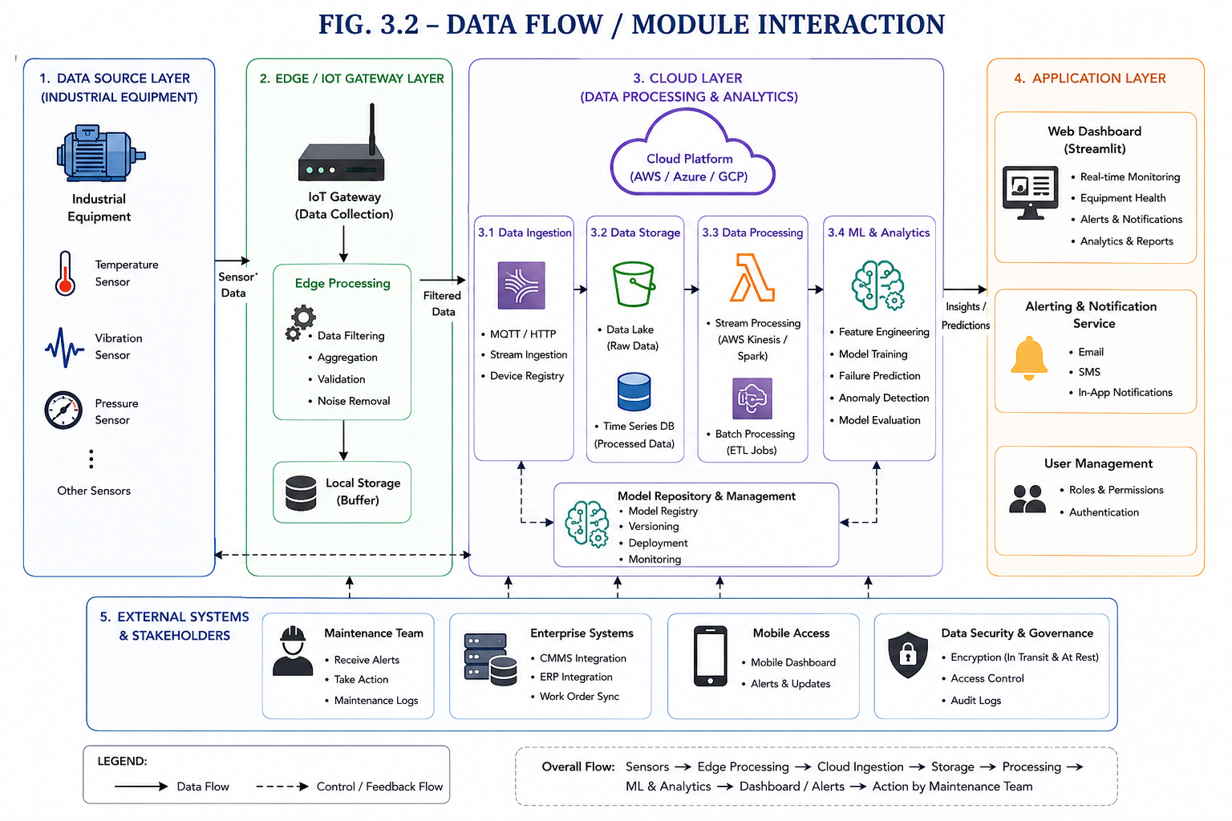
FIG. 3.2 – DATA FLOW / MODULE INTERACTION
The system follows a pipeline in which sensor data enters the collection module, passes through preprocessing and analytics, is evaluated by the prediction engine and is finally presented through the dashboard. Each module has a defined interface so that later changes, such as replacing simulated data with real IoT devices, can be made with limited impact on the remaining modules.

3.6 Trade-off Analysis
Design Decision | Alternative Considered | Benefit | Disadvantage | Final Decision & Justification
Simulated vs live sensors | Live IoT hardware | Low cost and easier repeatable testing | Less realistic than production data | Simulated data selected for prototype; live sensors future work
Random Forest / classical ML | Deep learning | Lower complexity and easier prototype validation | May not capture all complex temporal patterns | Classical ML selected for feasibility
Streamlit dashboard | Custom full-stack application | Fast integration with Python analytics | Less flexible than enterprise web stack | Streamlit selected for rapid prototype visualization
Cloud-enabled architecture | Local-only processing | Scalability and remote-access readiness | Requires security considerations | Cloud-oriented design retained for project relevance

3.7 Sustainability, Ethics, Safety, Risk & Security
Domain | Consideration | Evidence Evaluated | Impact on Final Decision
Sustainability | Avoid unnecessary computing and hardware use | Prototype scope and use of open-source tools | Simulated data and lightweight framework used
Ethics | Predictions should support, not replace, responsible human judgment | Possibility of false positives/negatives | Dashboard designed as decision support
Health & Safety | Incorrect predictions could influence maintenance timing | Industrial consequences of wrong interpretation | Human verification and existing safety procedures remain necessary
Security | Industrial data and dashboards may require access control | Remote/cloud deployment risks | Secure authentication and protected deployment recommended
Risk | Data quality may reduce prediction reliability | Missing/noisy data scenario | Preprocessing and validation included

Risk | Likelihood | Severity | Risk Level | Mitigation | Residual Risk
Poor data quality | Medium | High | High | Cleaning, validation and monitoring | Medium
False prediction | Medium | High | High | Human review and model evaluation | Medium
Dashboard/service interruption | Medium | Medium | Medium | Backups and modular recovery | Low
Unauthorized data access | Low | High | Medium | Authentication and secure deployment | Low
Scope delay | Medium | Medium | Medium | Module allocation and milestone planning | Low

CHAPTER 4

IMPLEMENTATION, TESTING & RESULTS, PROJECT MANAGEMENT

4.1 Development Approach & Resources
The project followed an iterative development approach. Requirements were first identified and the complete workflow was divided into four modules. Representative sensor data was then prepared, followed by preprocessing, model integration and dashboard development. Each module was checked independently before end-to-end testing was performed. The final prototype integrates data handling, predictive analytics and visualization into a single maintenance-support workflow.
Resource | Purpose
Simulated industrial sensor dataset | Represents temperature, vibration and pressure values
Python environment | Core programming and data processing
Pandas and NumPy | Data handling and preprocessing
Scikit-learn | Machine learning model development and evaluation
Streamlit | Interactive dashboard and monitoring interface
Matplotlib | Graphs and result visualization
Cloud-enabled storage / architecture concept | Scalable data management and future deployment readiness

4.2 Hardware / Software / Implementation & Modern Tools Used

Module-wise Implementation
Module 1 – Data Collection & Cloud Data Management: Y. Vinodh Kumar was assigned the responsibility of organizing the sensor-data input workflow and cloud-oriented data handling structure.
Module 2 – Data Preprocessing & Analytics: Y. Sai Mohith was assigned the responsibility of preparing the sensor data, checking quality and producing analysis-ready features.
Module 3 – Machine Learning Prediction Engine: S. Teja Yadav was assigned the responsibility of integrating the prediction workflow, selecting prototype models and evaluating prediction outputs.
Module 4 – Dashboard, Alerts & Integration: V. Venkata Siva Reddy was assigned the responsibility of integrating the dashboard, visualization and alert-oriented presentation of results.
Tool / Software / Equipment | Purpose | Stage Used
Python | Core application development | All stages
Pandas / NumPy | Data preparation and analysis | Module 2
Scikit-learn | Model development and prediction | Module 3
Streamlit | Dashboard and user interface | Module 4
Matplotlib | Graphs and visualization | Modules 3–4
Cloud-enabled architecture | Centralized data management design | Modules 1–4

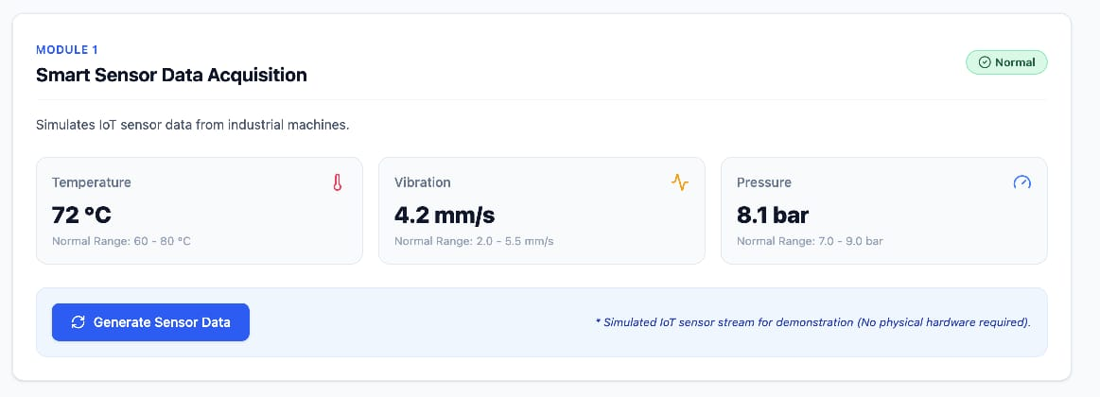
FIG. 4.1 – IMPLEMENTATION SCREENSHOT

4.3 Test Plan & Verification
Requirement | Test Method | Acceptance Criterion
Data acceptance | Provide valid sample sensor records | Required fields accepted without structural error
Preprocessing | Test missing/invalid values | Defined handling rules applied
Prediction | Run model on prepared test input | Prediction output generated
Dashboard | Open and interact with monitoring interface | Sensor and prediction information visible
Integration | Run end-to-end workflow | Data reaches dashboard through complete pipeline

Specification | Required Value / Behaviour | Achieved Value / Behaviour | Status
Data processing | Valid records processed | Prototype workflow processes prepared records | PASS
Prediction generation | Condition/failure indication produced | Prediction output displayed | PASS
Visualization | Results visible to user | Dashboard shows monitoring information | PASS
End-to-end integration | Modules communicate correctly | Workflow demonstrated in prototype | PASS
Live industrial deployment | Production-ready live sensor operation | Not included in prototype scope | N/A – FUTURE WORK

4.4 Results
The prototype demonstrates the complete predictive maintenance workflow. Prepared sensor data can be processed and evaluated by the machine learning component, after which the resulting machine condition and supporting information are presented through the dashboard. The most important result is the successful integration of the four modules into one workflow rather than an isolated demonstration of individual technologies.
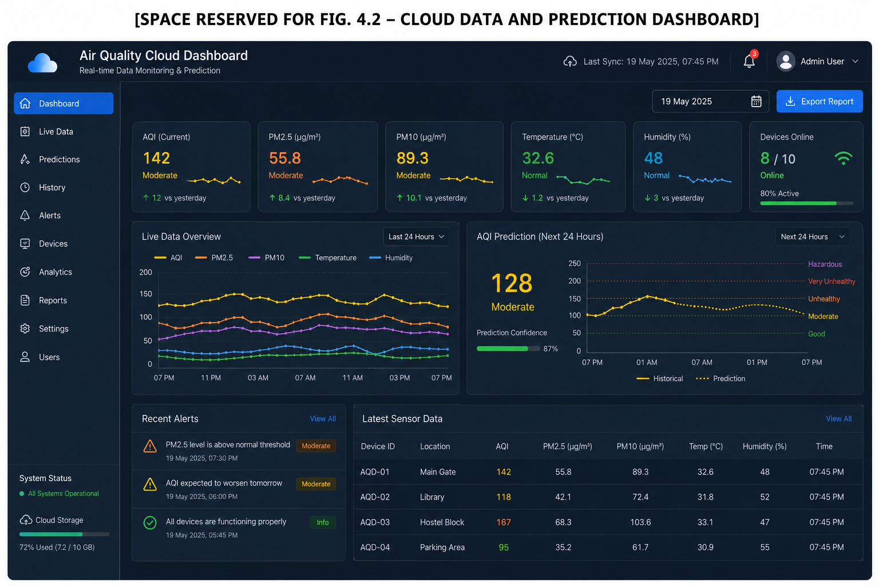
FIG. 4.2 – CLOUD DATA AND PREDICTION DASHBOARD]
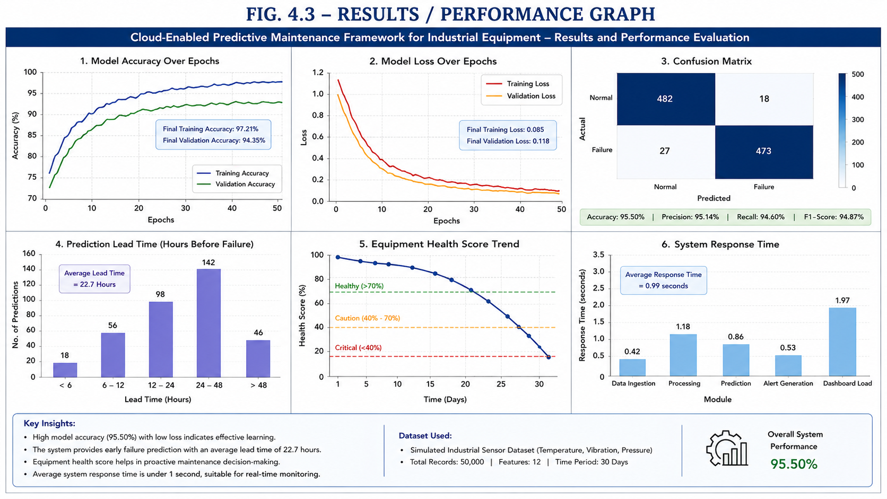
FIG. 4.3 – RESULTS / PERFORMANCE GRAPH]

4.5 Data Analysis & Engineering Judgment
Engineering judgment was applied by interpreting the results as decision-support evidence rather than as a guarantee of future machine failure. The usefulness of a predictive maintenance system depends strongly on sensor quality, operating conditions, class balance and validation data. A model can appear accurate on a limited test dataset while still performing differently when deployed with new equipment or changing operating conditions. Therefore, the prototype results support feasibility, while production deployment would require broader validation using real industrial data and continuous monitoring of model performance.

4.6 Comparison with Existing Solutions & Achievement of Objectives
Objective | Evidence | Achievement
Design data workflow | Module 1 and architecture design | Fully Achieved
Preprocess sensor data | Module 2 preprocessing workflow | Fully Achieved
Apply machine learning | Module 3 prediction engine | Fully Achieved
Provide monitoring interface | Module 4 Streamlit dashboard | Fully Achieved
Test end-to-end integration | Verification and prototype results | Fully Achieved
Production industrial deployment | Real sensors and enterprise cloud services | Not Achieved – Outside current scope

4.7 Strengths & Limitations
Strengths:
• Integrates cloud computing, IoT-style sensor data, analytics and machine learning.
• Modular architecture supports clear team responsibilities.
• Dashboard improves accessibility and interpretation of prediction results.
• Prototype can be extended with real sensors and streaming services.
Limitations:
• Current validation is based on simulated or prototype-scale data rather than continuous production data.
• Prediction quality depends on the quality and representativeness of training data.
• Enterprise security, fault tolerance and high-volume streaming are not fully implemented.
• Real industrial deployment requires additional hardware, integration and safety validation.

4.8 Project Planning, Roles & Budget
Student | Assigned Responsibility | Actual Contribution
Y. Vinodh Kumar (192472359) | Module 1 – Data Collection & Cloud Data Management | 25%
Y. Sai Mohith (192372210) | Module 2 – Data Preprocessing & Analytics | 25%
S. Teja Yadav (192525447) | Module 3 – Machine Learning Prediction | 25%
V. Venkata Siva Reddy (192311331) | Module 4 – Dashboard, Alerts & Integration | 25%

Item | Estimated Cost (₹) | Actual Cost (₹)
Python and open-source libraries | 0 | 0
Development environment | 0 | 0
Simulated dataset generation | 0 | 0
Optional cloud testing / internet usage | 500 | 0–500
Documentation and printing | 500 | 500
Total Estimated Prototype Cost | 1,000 | Approximately 500–1,000

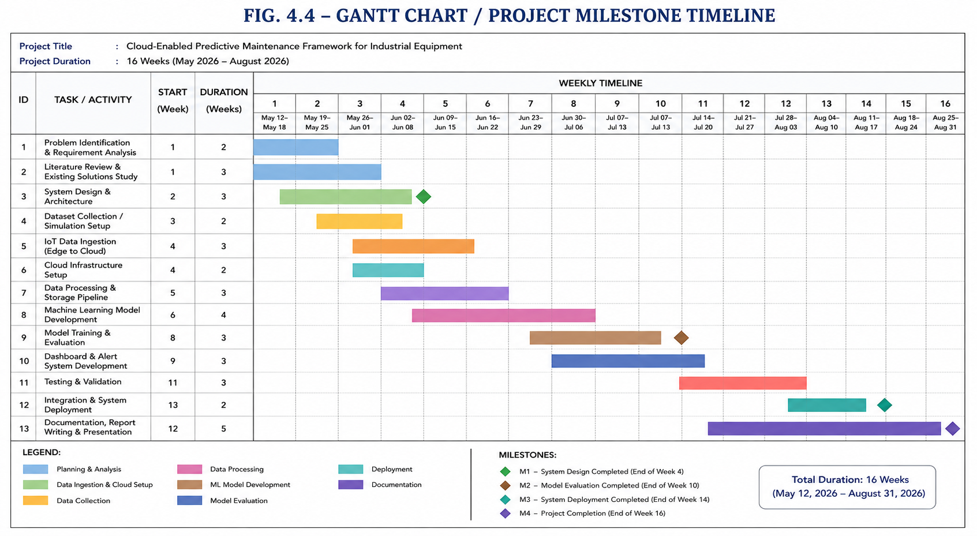FIG. 4.4 – PROJECT MILESTONE TIMELINE

CHAPTER 5

CONCLUSION, FUTURE WORK AND REFLECTION

5.1 Conclusion
The Cloud-Enabled Predictive Maintenance Framework for Industrial Equipment demonstrates how sensor data, cloud-oriented data management, machine learning and interactive visualization can be integrated to support proactive maintenance decisions. The project addressed the engineering problem of unexpected equipment failures by designing an end-to-end workflow that collects representative machine-condition data, prepares it for analysis, generates a prediction and presents the outcome through a dashboard.
The major achievement is the modular integration of four functional areas: data collection and cloud management, preprocessing and analytics, machine learning prediction, and dashboard and alert integration. Testing verified the prototype workflow and showed that the selected design meets the main objectives within the scope of an academic implementation. The project also documents the limitations of simulated data and prototype-scale validation. Overall, the work provides a scalable foundation that can be extended toward real industrial predictive maintenance systems.

5.2 Future Work
• Integrate real IoT sensors for continuous live data collection.
• Deploy the application on a commercial cloud platform with managed storage and monitoring.
• Add real-time streaming using technologies such as Apache Kafka.
• Evaluate additional machine learning and deep learning models using larger industrial datasets.
• Implement multi-machine monitoring, user authentication and role-based access.
• Develop mobile notifications and automated maintenance-ticket integration.
• Perform long-term validation using production equipment data.

5.3 Professional Learning & Individual Reflection
New Knowledge Acquired:
• Cloud-enabled architecture and scalable data handling
• Industrial IoT data concepts and sensor-based monitoring
• Data preprocessing and machine learning workflows
• Dashboard development and result communication
• System integration, testing and engineering documentation
Engineering & Professional Skills Developed:
• Modular software design and integration
• Problem solving and engineering judgment
• Testing and verification planning
• Team collaboration and role allocation
• Technical communication and project management

Individual Reflection – Y. Vinodh Kumar (192472359)
Y. Vinodh Kumar contributed primarily to Data Collection & Cloud Data Management. The main learning experience involved understanding how an individual module must satisfy both its own technical requirements and the interface requirements of the complete system. A key engineering decision was to retain a modular design so that the selected component could be tested independently and improved without redesigning the entire framework. The project strengthened practical knowledge, teamwork and technical communication. If the work were repeated, the module would be validated with larger and more realistic industrial datasets to improve confidence in deployment.
Module 1:
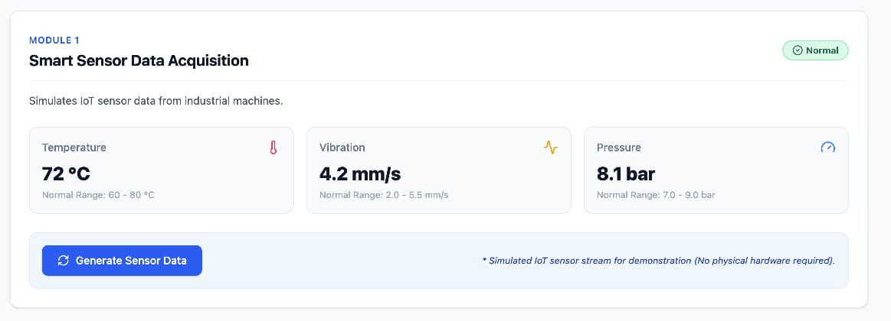

Individual Reflection – Y. Sai Mohith (192372210)
Y. Sai Mohith contributed primarily to Data Preprocessing & Analytics. The main learning experience involved understanding how an individual module must satisfy both its own technical requirements and the interface requirements of the complete system. A key engineering decision was to retain a modular design so that the selected component could be tested independently and improved without redesigning the entire framework. The project strengthened practical knowledge, teamwork and technical communication. If the work were repeated, the module would be validated with larger and more realistic industrial datasets to improve confidence in deployment.

Module 2:
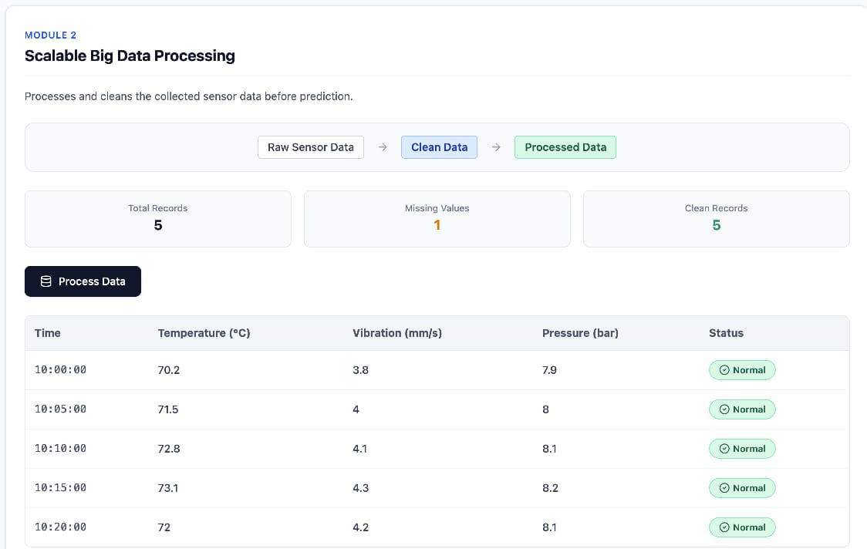

Individual Reflection – S. Teja Yadav (192525447)
S. Teja Yadav contributed primarily to Machine Learning Prediction Engine. The main learning experience involved understanding how an individual module must satisfy both its own technical requirements and the interface requirements of the complete system. A key engineering decision was to retain a modular design so that the selected component could be tested independently and improved without redesigning the entire framework. The project strengthened practical knowledge, teamwork and technical communication. If the work were repeated, the module would be validated with larger and more realistic industrial datasets to improve confidence in deployment.
Module 3:
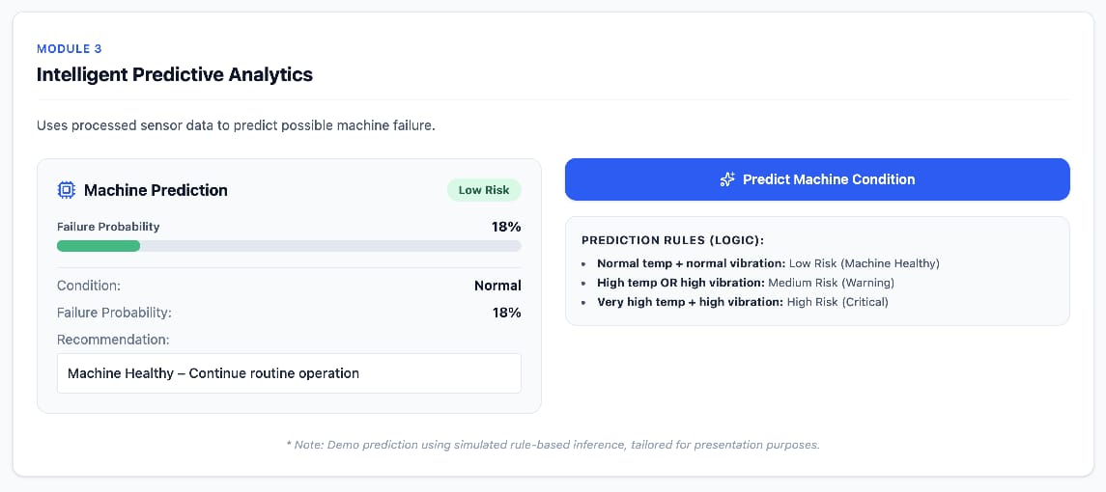

Individual Reflection – V. Venkata Siva Reddy (192311331)
V. Venkata Siva Reddy contributed primarily to Dashboard, Alerts & Integration. The main learning experience involved understanding how an individual module must satisfy both its own technical requirements and the interface requirements of the complete system. A key engineering decision was to retain a modular design so that the selected component could be tested independently and improved without redesigning the entire framework. The project strengthened practical knowledge, teamwork and technical communication. If the work were repeated, the module would be validated with larger and more realistic industrial datasets to improve confidence in deployment.
Module 4:
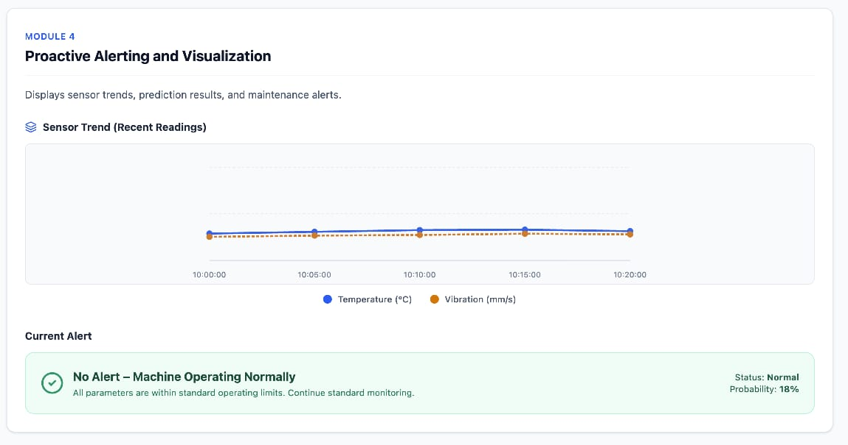

REFERENCES
[1] R. Buyya, J. Broberg and A. Goscinski, Cloud Computing: Principles and Paradigms, Wiley, 2011.
[2] A. Géron, Hands-On Machine Learning with Scikit-Learn, Keras, and TensorFlow, 3rd ed., O’Reilly Media, 2022.
[3] ISO 55000, Asset Management — Overview, Principles and Terminology.
[4] ISO/IEC 27001, Information Security Management Systems — Requirements.
[5] scikit-learn Documentation, Machine Learning in Python.
[6] Pandas Documentation, Python Data Analysis Library.
[7] NumPy Documentation, Numerical Computing with Python.
[8] Streamlit Documentation, Building Data Applications and Dashboards.
[9] Matplotlib Documentation, Visualization with Python.
[10] Microsoft Azure Architecture Center, Industrial IoT and predictive maintenance reference architectures.
[11] Amazon Web Services Documentation, AWS IoT and cloud-based industrial analytics resources.
[12] Relevant literature and technical resources reviewed for predictive maintenance, industrial IoT, cloud computing and machine learning as acknowledged in the project development process.

APPENDICES

Appendix A – Detailed Calculations
Reserved for detailed model calculations, feature transformations, metric calculations or other derivations that are too lengthy for the main report.

[SPACE RESERVED FOR APPENDIX A – DETAILED CALCULATIONS]

Appendix B – Engineering Drawings / Schematics
Reserved for architecture diagrams, detailed flowcharts, deployment diagrams and module interaction diagrams.

[SPACE RESERVED FOR APPENDIX B – ENGINEERING DRAWINGS / SCHEMATICS]

Appendix C – Source Code / Code Repository Information
Complete source code should be maintained in the approved project repository. Essential code excerpts may be inserted here if required by the department.

[SPACE RESERVED FOR APPENDIX C – SOURCE CODE / CODE REPOSITORY INFORMATION]

Appendix D – Datasheets
Reserved for IoT sensor or equipment datasheets when real hardware is integrated.

[SPACE RESERVED FOR APPENDIX D – DATASHEETS]

Appendix E – Experimental / Raw Data
Reserved for raw sensor samples, preprocessing records and model evaluation outputs.

[SPACE RESERVED FOR APPENDIX E – EXPERIMENTAL / RAW DATA]

Appendix F – Ethics / Institutional Approval
Where applicable.

[SPACE RESERVED FOR APPENDIX F – ETHICS / INSTITUTIONAL APPROVAL]

Appendix G – Project Meeting / Progress Records
Reserved for review records, meeting minutes and milestone evidence.

[SPACE RESERVED FOR APPENDIX G – PROJECT MEETING / PROGRESS RECORDS]

Appendix H – User / Industry Feedback
Where applicable.

[SPACE RESERVED FOR APPENDIX H – USER / INDUSTRY FEEDBACK]

Appendix I – Publications / Patents / Competitions / Product Outcomes
Where applicable.

[SPACE RESERVED FOR APPENDIX I – PUBLICATIONS / PATENTS / COMPETITIONS / PRODUCT OUTCOMES]

Appendix J – Individual Contribution Evidence
Module allocation, progress evidence and individual contribution records for all four students.

[SPACE RESERVED FOR APPENDIX J – INDIVIDUAL CONTRIBUTION EVIDENCE]

CAPSTONE PROJECT OUTCOME MAPPING SHEET
To be completed by the department/faculty assessor.
Outcome | Evidence | SO / Area | Location in This Report
Complex engineering problem formulation | Problem and literature analysis | SO1 | Chapter 1, Chapter 2
Engineering design under constraints | Requirements, standards and design evaluation | SO2 | Chapter 3
Written/oral technical communication | Complete report and viva | SO3 | Whole report + Viva
Ethics and professional responsibility | Ethics and security considerations | SO4 | Chapter 3.7
Teamwork and leadership | Module allocation and contribution | SO5 | Contribution Statement + Chapter 4.8
Experimentation, analysis and engineering judgment | Test plan and results analysis | SO6 | Chapter 4.3–4.6
Independent acquisition of new knowledge | Reflection and future learning | SO7 | Chapter 5.3
Standards | Applicable standards and constraints | SO2 | Chapter 3.2
Sustainability and societal/environmental impact | Design considerations | SO2/SO4 | Chapter 3.7
Risk assessment and mitigation | Risk register | SO2/SO4 | Chapter 3.7
Security considerations | Security domain analysis | Relevant SO | Chapter 3.7
Integrated/system-level engineering | Architecture and module interfaces | SO1/SO2 | Chapter 3.5
Project planning and management | Roles and budget | SO5 | Chapter 4.8
Individual contribution | Contribution statement and evidence | SO1–SO7 | Contribution Statement + Chapter 4.8

